All wrong
This document will pass automated tests even though it contains XX number of accessibility barriers to access ranging from mild to substantial blockers.

Images
This image has complete gibberish for alt text but will pass an automated checker because it has an alt attribute assigned to it. None of these checkers will flag this (Microsoft, Acrobat, nor Ally).
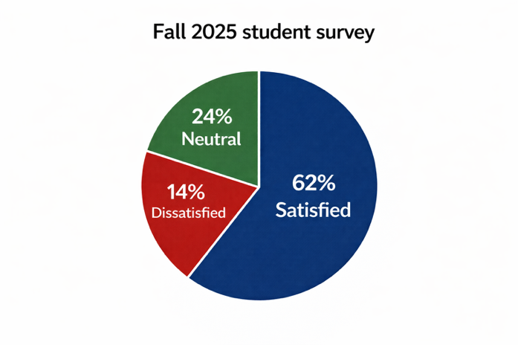
Fix, by adding this correct alt text:
A pie chart of the Fall 2025 Student Survey showing 62% satisfied, 14% dissatisfied, and 24% neutral.
Headings
The text directly above is not actually a heading. It only looks like one. This entire piece of text here is a child (i.e., is nested underneath) the heading level two above, Images.
Fix by using the heading styles provided in Word or Canvas Rich Text Editor. For PowerPoint, you’re limited to slide titles creating an H1 on main title, and H2 on each subsequent slide.

Tables as layout devices
This content is using tables for layout instead of data. This creates confusing semantics for screen readers. To pass the checker, the first row was set to be column headers. This is a common occurrence when people want visual formatting like in this example.
First name: | Damian
Last name: | Sian
Occupation: | Adjunct professor
Department: | School of Information and Communication
Notice that when this table above spans more than one page, the first row repeats. This passes automated checkers but is super confusing for just about everyone.
Fix by setting tab stops in MS Office apps in the page ruler like shown here.
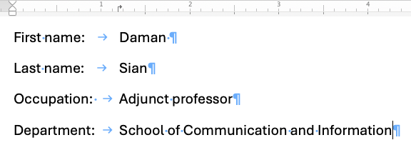

Complex tables
To come.

Reading order
To come.

Color as sole means of communication
To come.

Contrast
To come.

Metadata
The document title has been set to “Blah, blah, blah.” In a PDF conversion of this document, that’d be the very first thing a screen reader user hears. This approach will pass every automated checker there is, even PAC 4 PDF Accessibility Checker based on the Matterhorn protocol.

